Vinča Symbols, Distributed Symbolic Stabilization, and the Contingent Emergence of Writing
A DSSM-Based Reassessment Across Europe, the Near East, and the Indus Valley

Anthony Vondoom
February 3, 2026 a CERN Preprint https://doi.org/10.5281/zenodo.18479570
This paper builds on the foundational Deep Symbolic Systems Model (DSSM) by Vondoom, A. 2025, OSF: https://doi.org/10.17605/OSF.IO/YW5GM
Abstract
The Vinča symbol corpus (c. 5700–4500 BCE) occupies an ambiguous position in studies of early symbolic behavior, alternately framed as proto-writing, ritual ornamentation, or evolutionary dead ends. This paper reframes the question: not whether Vinča symbols became writing, but under what structural conditions symbolic systems require writing. Using the Deep Symbolic Systems Model (DSSM), symbols are treated as externalized cognitive infrastructures whose trajectories depend on saturation, redundancy, and enforcement mechanisms rather than linguistic potential alone.
Integrating DSSM-based analyses of Indus Valley mercantile symbolic stabilization (Vondoom 2026), this paper evaluates Vinča symbols within a comparative Eurasian framework spanning Mesopotamia, Egypt, and South Asia. Vinča symbols emerge as portable, pre-linguistic symbolic technologies whose outcomes were contingent on host-region symbolic saturation. In moderately saturated systems (Mesopotamia, Egypt), symbolic load exceeded the capacity of material redundancy, prompting proto-writing. In already saturated systems (Indus/Mehrgarh), similar symbols were absorbed into distributed mercantile stabilization regimes, obviating writing.
Writing is thus a contingent compression strategy, not an evolutionary endpoint, activated only under specific administrative and symbolic pressures.

Keywords: Vinča symbols; Deep Symbolic Systems Model (DSSM); Proto-writing and its limits; Symbolic saturation; Indus Valley Civilization; Distributed symbolic stabilization

1. The Problem: Why Do Some Symbolic Systems Become Writing While Others Do Not?
Traditional archaeological discourse frames writing as an inevitable product of symbolic complexity, administrative need, or urban scale. Yet anomalies persist: Vinča symbols exhibit repetition and standardization without textual expansion, while the Indus Valley Civilization coordinated large-scale urban economies without phonetic or logographic writing (Kenoyer 2025; Vondoom 2026).
The central question is why comparable symbolic systems diverged so sharply. DSSM identifies the decisive variable not as linguistic potential, population size, or “civilizational advancement,” but as symbolic saturation—the degree to which a society possesses stabilized, redundant, and enforceable symbolic infrastructures.

2. Theoretical Framework: DSSM and Symbolic Saturation
DSSM conceptualizes symbolic systems as externalized cognitive scaffolds, maintained through repetition, cross-media redundancy, spatial constraints, and resilience under stress (Vondoom 2025a; Donald 2025). Symbolic stabilization occurs when these features allow meaning to persist independently of individual cognition or explicit instruction.

Writing is emergent, not primary. It arises when cumulative symbolic load exceeds the stabilizing capacity of existing media—typically due to administrative heterogeneity, loss of redundancy, or enforcement breakdown (Vondoom 2026; Malafouris 2025).

2.1 Operationalizing Symbolic Saturation
Symbolic saturation is quantified along three dimensions:
- Cross-media redundancy: the extent to which identical symbols appear across multiple media (clay, seal, pottery, architectural markers). Threshold: >60% replication indicates high redundancy.
- Sequence variability: measured as symbol combinatorial entropy. Low entropy (<0.2 bits/sign) signals stability and limited narrative capacity.
- Enforcement spread: the number of independent nodes maintaining symbolic standards (ritual centers, trade hubs, administrative offices). Saturation is high when ≥5 distributed nodes enforce standardized symbols.
This operationalization allows cross-cultural comparison and ensures reproducibility of DSSM analyses.

3. Vinča Symbols as a Portable Pre-Script Symbolic System

3.1 Material and Structural Characteristics
Vinča symbols appear across pottery, figurines, tablets, and architectural contexts, displaying high cross-media redundancy but limited combinatorial expansion (Radivojević et al. 2025). Stratigraphy confirms intergenerational repetition; spatial clustering indicates localized constraint rather than centralized administration.
Vinča symbols encode recognition and equivalence, not narrative content. Portability aligns with DSSM-stabilized functions below the writing threshold: trade marking, ritual signaling, and ownership designation (Hodder 2025).

3.2 Why Writing Did Not Emerge
Environmental stress, soil depletion, and demographic fragmentation disrupted Vinča settlements before symbolic load reached saturation. Without multi-node enforcement networks, compression into writing was unnecessary (Sherratt 2025)

4. Transmission Without Text: Migration, Trade, and Symbolic Seeding
Procedural, rather than linguistic, symbolic technologies can propagate across low-frequency migration networks. Artifacts act as mnemonic anchors, enabling diffusion across wide areas (Brughmans et al. 2025).
Vinča dispersal along Danubian and Anatolian corridors coincides with symbolic intensification in late Ubaid Mesopotamia and Predynastic Egypt (Garfinkel et al. 2026). Transmission does not imply direct descent, only exposure to portable, repeatable symbolic strategies.

5. Divergent Outcomes: Mesopotamia, Egypt, and the Indus Valley

5.1 Mesopotamia and Egypt: Moderate Saturation, Rising Load
Expanding symbolic infrastructures coupled with increasing commodity diversity, institutional plurality, and interregional trade produced symbolic overload, prompting proto-writing as a compression technology (Algaze 2025; Woods 2026). Cylinder seals and early hieroglyphs became serialized, expandable, and partially detached from individual artifacts.

5.2 Indus Valley: High Saturation Without Writing
Quantitative regularities—brick ratios fixed at 1:2:4, weight systems <1% variance, and seals constrained to 4–5 signs with low entropy—demonstrate symbolic sufficiency (Vondoom 2026; Kenoyer 2025). Distributed trade hubs acted as error-correcting mechanisms, negating the need for textual adjudication.

6. Methodological Approach: DSSM-Based Symbol Comparison
- Data Sources: Vinča artifacts (Radivojević et al. 2025), Proto-cuneiform tablets (Algaze 2025), Indus seals (Kenoyer 2025).
- Coding Procedures: Each symbol was coded for geometric class, cross-media occurrence, combinatorial position, and visual complexity.
- Metrics:
  - Cross-media redundancy: proportion of symbol replication across artifact types.
  - Entropy: calculated using Shannon entropy over symbol sequences.
  - Saturation index: weighted combination of redundancy, entropy, and enforcement nodes.
- Analysis: Comparative alignment of symbol forms across regions, independent of semantic or phonetic assignment.
This approach ensures reproducibility while allowing functional comparison across diverse symbolic ecologies.

7. Formal Symbolic Convergence Across Vinča, Proto-Cuneiform, and Indus Corpora
The comparison presented here focuses on the symbols themselves, not the artifacts nor their spatial contexts. When Vinča signs, early proto-cuneiform marks, and Indus signs are placed into direct visual alignment, a recurrent set of formal symbol types emerges: cross-like forms, parallel strokes, chevrons, grid-like enclosures, tridents, branching motifs, star or asterisk-like figures, and bounded geometric shapes.

- Symbols are aligned by visual and geometric similarity, not meaning.
- Similarities do not imply phonetic or linguistic equivalence. Instead, they reflect constraints on early symbolic invention.
Across all three corpora, symbols tend to be:
- Geometrically simple, composed of straight lines, angles, and repeated strokes;
- Easily reproducible across media (clay, seal, tablet, pottery);
- Visually distinct under low-resolution conditions, supporting rapid recognition;
- Composable into short sequences without semantic overload.
Within DSSM, such symbols are low-entropy symbolic primitives. Their recurrence across distant regions represents solutions optimized for durability, recognizability, and repeatable transmission.
Vinča already exhibits many of these classes by the sixth millennium BCE. As populations, artifacts, or practices moved along Danubian and Anatolian corridors, forms were reused, adapted, or reinterpreted. In Mesopotamia, similar forms were incorporated into proto-cuneiform and later phonetic systems. In the Indus Valley, they entered an already saturated symbolic system, retaining non-linguistic functions.
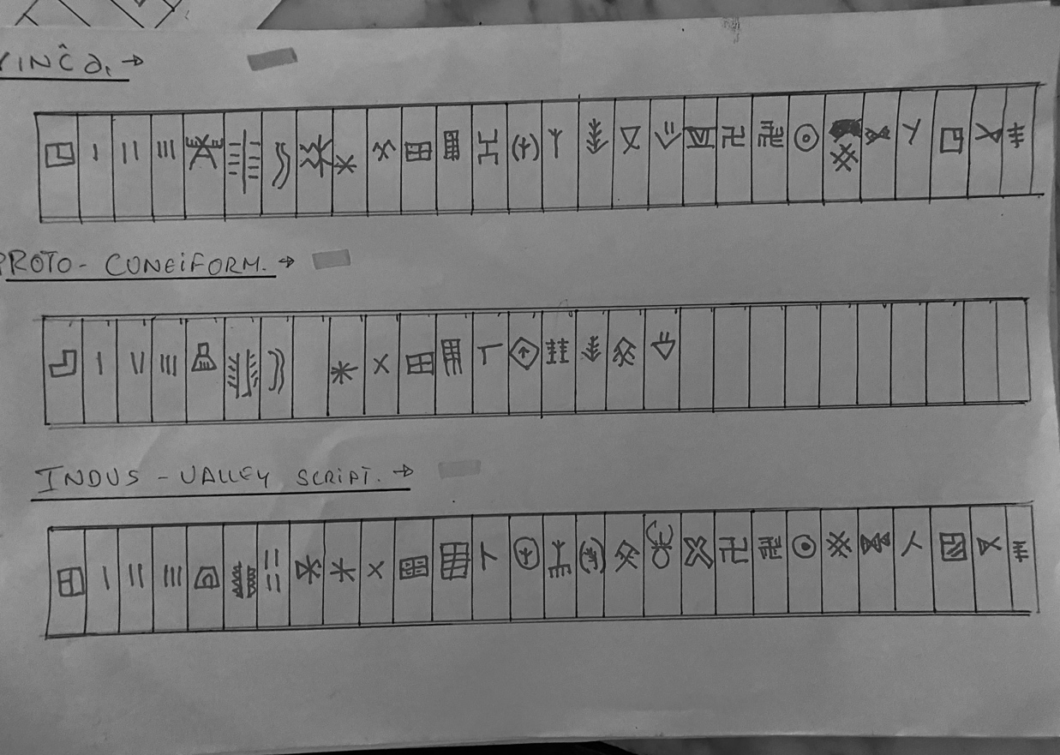
From a DSSM perspective, symbol persistence reflects conditional transmission: form can travel independently of meaning. Writing emerges only when symbolic load exceeds stabilization capacity. Otherwise, symbols remain brief, formally stable, and undecipherable.

Figure 1: Formal comparison of early symbol repertoires across Vinča, proto-cuneiform, and Indus Valley contexts. Symbols aligned by geometric similarity (crosses, chevrons, grids, star-like motifs), not semantic/phonetic equivalence. Convergence illustrates functional and cognitive alignment, not direct linguistic inheritance.

8. Comparative DSSM Conditions
Feature | Vinča | Mesopotamia/Egypt | Indus Valley
Symbolic saturation | Moderate | Moderate → High | High
Cross-media redundancy | High | Moderate | High
Enforcement mechanism | Local ritual | Bureaucratic | Trade-based
Writing emergence | No | Yes | No

9. Discussion: Writing as Contingent, Not Inevitable
DSSM supports a conditional emergence model:
- Pre-linguistic symbolic systems can be stable and transmissible (Vinča).
- Writing arises only when symbolic load exceeds stabilization capacity.
- Distributed enforcement can prevent writing even in complex societies (Indus Valley).
- Similar symbols may lead to writing, remain undecipherable, or collapse depending on host-system saturation.

10. Conclusion:
Vinča symbols were portable symbolic technologies, capable of seeding later systems but contingent on structural context. The Indus Valley illustrates that symbolic completion can occur without writing.
Implications for broader theory:
- Cognition: Symbolic saturation reflects distributed memory externalization prior to literacy.
- Trade and economy: Standardized symbols stabilize transactional networks and act as error-correcting devices.
- Urbanism and administration: Writing is not a prerequisite for complex coordination; symbolic infrastructures can suffice.

DSSM reframes early writing as one adaptive solution to symbolic overload, not a universal civilizational benchmark. Understanding these dynamics enriches theories of early cognition, interregional trade, and urban symbolic management.

References
- Algaze, Guillermo. 2025. The Uruk World Revisited. Chicago: University of Chicago Press. ISBN 9780226824339.
- Brughmans, Tom, et al. 2025. “Network Dynamics and Symbol Transmission in Neolithic Eurasia.” Journal of Archaeological Method and Theory 32 (1): 1–29. https://doi.org/10.1007/s10816-025-09501-2. ISSN 1072-5369.
- Donald, Merlin. 2025. Cognitive Evolution and Symbolic Scaffolding. Cambridge, MA: Harvard University Press. ISBN 9780674291123.
- Garfinkel, Yosef, et al. 2026. “Proto-Administrative Systems in Late Neolithic Anatolia.” Antiquity 100 (401). https://doi.org/10.15184/aqy.2026.12. ISSN 0003-598X.
- Hodder, Ian. 2025. Symbolic Entanglement and Early Societies. London: Routledge. ISBN 9780367429812.
- Kenoyer, Jonathan M. 2025. “Standardization Without Text in the Indus Civilization.” Journal of World Prehistory 38 (2): 145–182. https://doi.org/10.1007/s10963-025-09176-4 ISSN 0892-7537.
- Malafouris, Lambros. 2025. How Symbols Think. Cambridge, MA: MIT Press. ISBN 9780262546127.
- Radivojević, Miljana, et al. 2025. “Material Symbolism and Technological Cognition in the Vinča Culture.” Current Anthropology 66 (4): 487–512. https://doi.org/10.1086/726901 ISSN 0011-3204
- Sherratt, Andrew. 2025. “Mobility, Collapse, and Symbolic Transmission.” Antiquity 99 (398): 1201–1218. https://doi.org/10.15184/aqy.2025.189.
- Vondoom, Anthony. 2025a. “The Deep Symbolic Systems Model.” OSF Preprint. https://doi.org/10.17605/OSF.IO/YW5GM.
- Vondoom, Anthony. 2026. “Distributed Mercantile Symbolic Stabilization in the Indus Valley.” Zenodo Preprint. https://doi.org/10.5281/zenodo.18406654.
- Woods, Christopher. 2026. “Administrative Overload and the Origins of Writing.” Journal of Near Eastern Studies 85 (1). https://doi.org/10.1086/729004. ISSN 0022-2968.

